BLM 2–8
Chapter 2 BLM Answers

BLM 2–1 Prerequisite Skills
1. a) 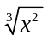 b)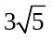 c) 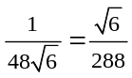 d)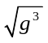
2. a) 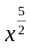 b) x c)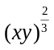 d)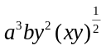
3. a)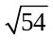 b)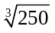 c) 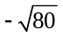
4. a)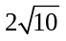 b)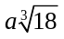 c) 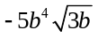 d)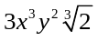
5. a) 15 b) 5 c) 70 d) 20
6. a) 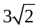 b) −6x⁴ c) 97 −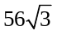 d)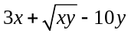
7. a) x  0 b) x ≥ 4 c) x > −2 and x  0 d) z ≥ 0
e)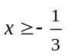 f ) d ≥ 1
8. a) False; 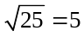 b) False; 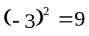
c) False; −2² = −4
9. a) 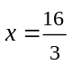 b)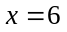 c) x ∈ R d) y  8 or y = −3
10. a) domain: 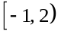; range: 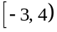
b) domain: [0, ); range: [0, ∞)
11. a) 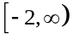 b) 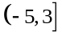 c)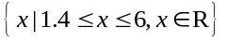
d)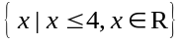
12. Example:
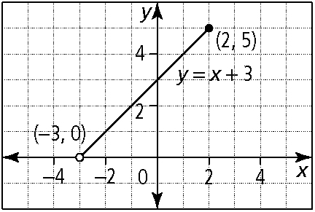
13. a) 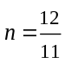 b) 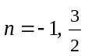 c)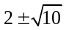
BLM 2–2 Section 2.1 Extra Practice
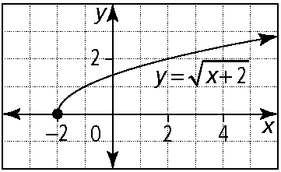
1. a)

domain: {x | x ≥ −2, x ∈ R}; range: { y | y ≥ 0, y ∈ R}
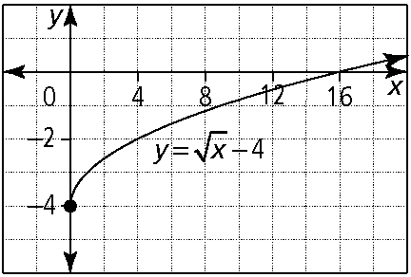
b)

domain: {x | x ≥ 0, x ∈ R}; range: { y | y ≥ −4, y ∈ R}
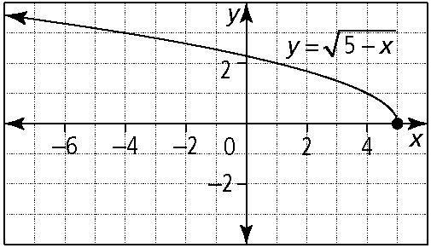
c)

domain: {x | x ≤ 5, x ∈ R}; range: { y | y ≥ 0, y ∈ R}
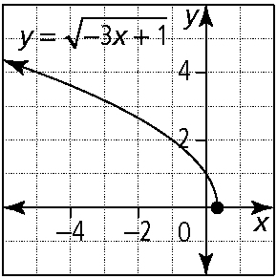
d)

domain: {x | x ≤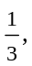 x ∈ R}; range: { y | y ≥ 0, y ∈ R}
2. a) vertical stretch by a factor of 3, translation right 5 units; domain: {x | x ≥ 5, x ∈ R}; range:
{ y | y ≥ 0, y ∈ R}
b) vertical reflection in the x-axis, translation up
7 units; domain: {x | x ≥ 0, x ∈ R}; range:
{ y | y ≤ 7, y ∈ R}
c) vertical stretch by a factor of 0.25, horizontal stretch by a factor of 4, translation down 3 units; domain: {x | x ≥ 0, x ∈ R}; range: { y | y ≥ −3, y ∈ R}
d) horizontal reflection in the y-axis, translation left
1 unit, translation down 5 units; domain:
{x | x ≤ −1, x ∈ R}; range: { y | y ≥ −5, y ∈ R}
3. a) D b) A c) C d) B
4. a)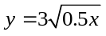 b)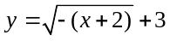
c)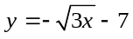 d)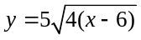
5. a) vertical stretch by a factor of 5, translation down 2 units, translation left 7 units
b) vertical stretch by a factor of 4, reflection in the
x-axis, reflection in the y-axis, translation up 8 units
c) horizontal stretch by a factor of 4, translation right 1 unit
d) horizontal stretch by a factor of 3, translation down 3 units, translation left 4 units

BLM 2–8
(continued)

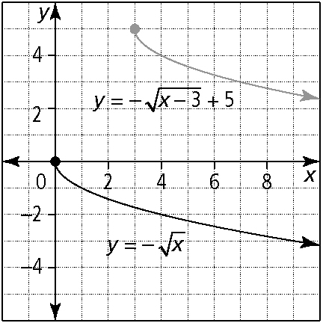
6. a)

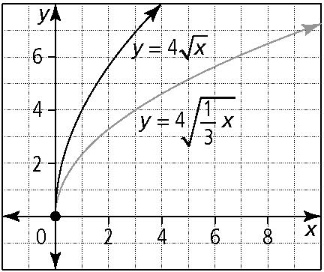
b)

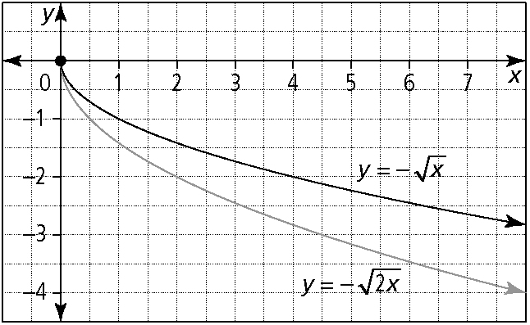
c)

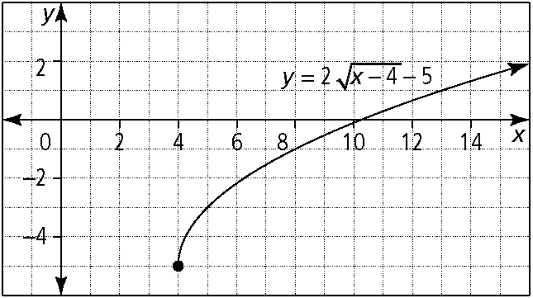
7. a)

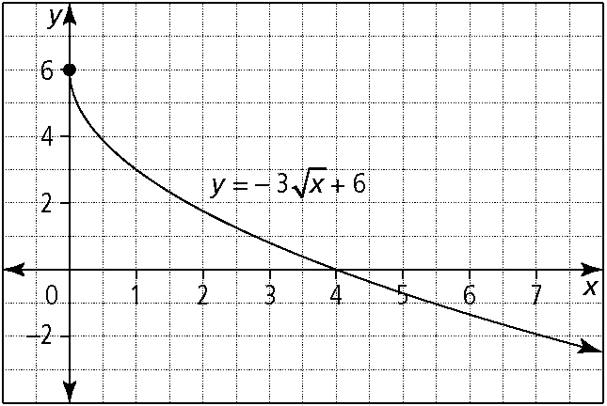
b)

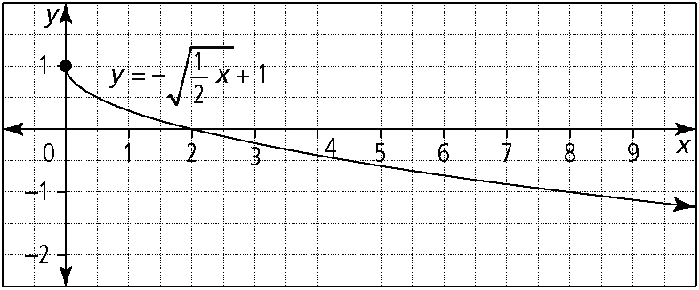
c)

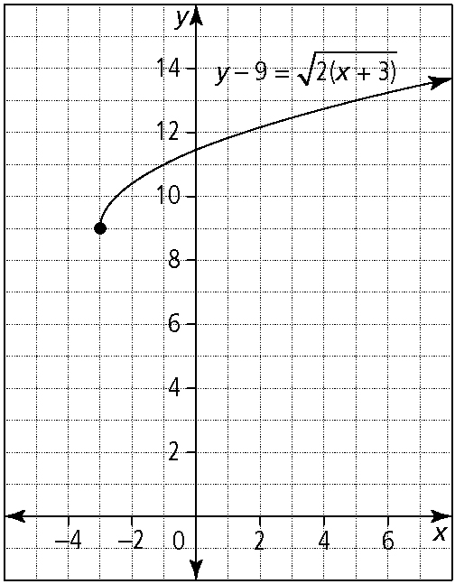
d)

8. a) domain: {x | x ≤ 0, x ∈ R}; range:
{ y | y ≥ −4, y ∈ R} b) domain: {x | x ≥ 4, x ∈ R}; range:{ y | y ≥ 0, y ∈ R} c) domain:
{x | x ≥ 4, x ∈ R}; range:{ y | y ≤ 4, y ∈ R}
d) domain: {x | x ≥ 0, x ∈ R}; range:
{ y | y ≤ 0, y ∈ R}
9. a)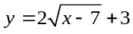 b)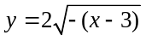 c)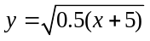
10. a) reflection in the y-axis, translation left 7 units
b) horizontal stretch by a factor of 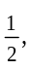 translation right 3 units, translation up 5 units
c) reflection in the y-axis, translation right 5 units, translation up 7 units
BLM 2–4 Section 2.2 Extra Practice
1. | x | f (x) | 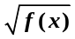
 | −2 | 16 | 4
 | −1 | 8 | 2.83
 | 0 | 4 | 2
 | 1 | 1.96 | 1.4
 | 2 | 1 | 1
2. a) (9, 3.74) b) ( p, 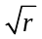) c) (−2, 2.65)
d) No corresponding point exists.
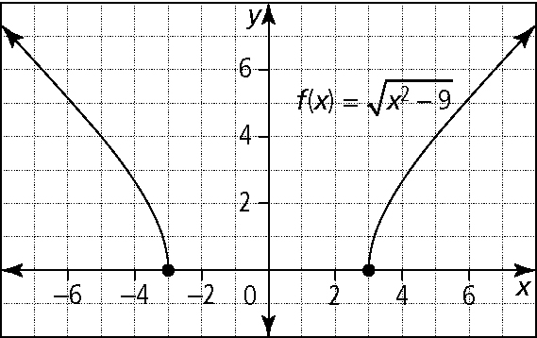
3. a)

BLM 2–8
(continued)

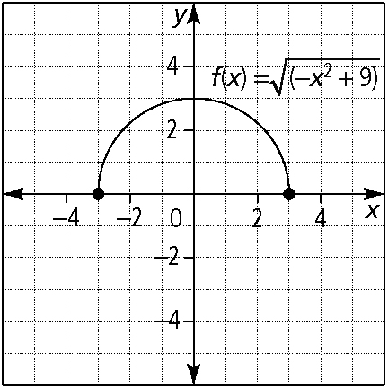
b)

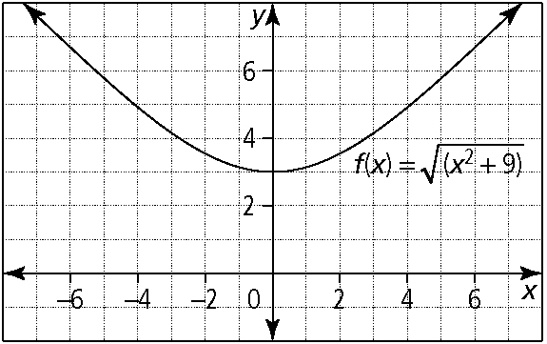
c)

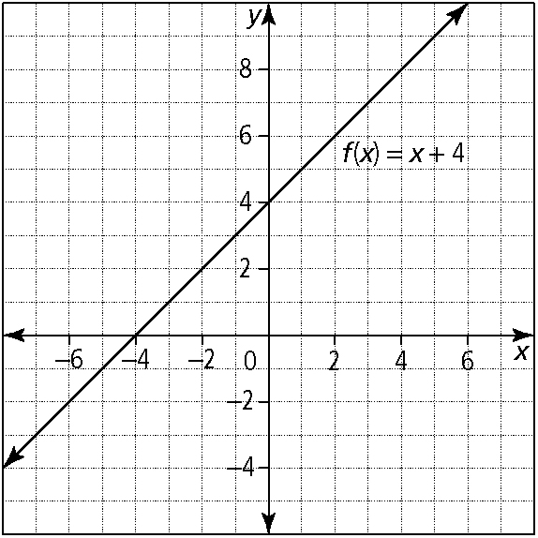
4. a)

b) domain: {x | x ∈ R}; range: { y | y ∈ R}
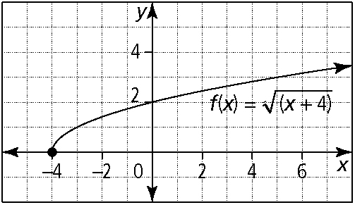
c)

d) domain: {x | x ≥ −4, x ∈ R};
range: { y | y ≥ 0, y ∈ R}
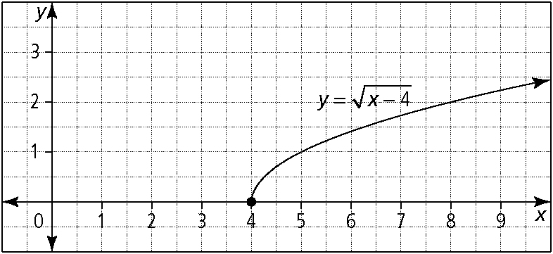
5. a)

domain: {x | x ≥ 4, x ∈ R}; range: {y | y ≥ 0, y ∈ R}
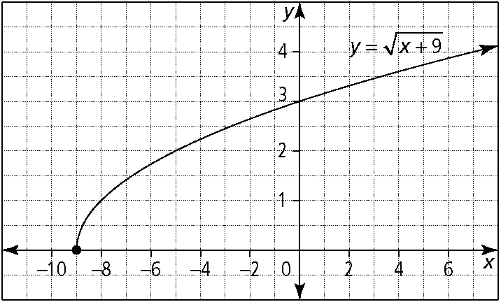
b)

domain: {x | x ≥ −9, x ∈ R}; range: { y | y ≥ 0, y ∈ R}
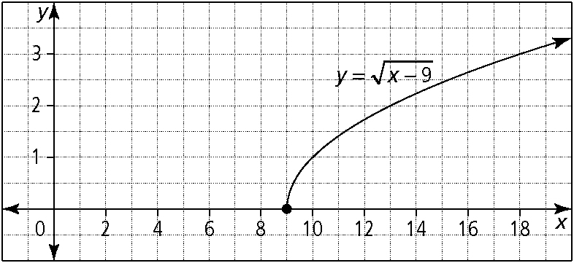
c)

domain: {x | x ≥ 9, x ∈ R}; range: { y | y ≥ 0, y ∈ R}
6. a) y = x + 5: domain: {x | x ∈ R},
range: { y | y ∈ R}; 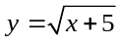: domain:
{x | x ≥ −5, x ∈ R}, range: { y | y ≥ 0, y ∈ R}
b) y = 3x − 9: domain: {x | x ∈ R}, range:
{ y | y ∈ R}; 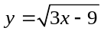: domain: {x | x ≥ 3, x ∈ R}, range: { y | y ≥ 0, y ∈ R}
c) y = −x − 10: domain:
{x | x ∈ R}, range: { y | y ∈ R}; 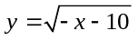: domain: {x | x ≤ −10, x ∈ R},
range: { y | y ≥ 0, y ∈ R}
7. a) domain: {x | x ≤ −4 and x ≥ 4 , x ∈ R};
range: { y | y ≥ 0, y ∈ R}
b) domain: {x | x ∈ R}; range: { y | y ≥ 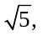 y ∈ R}
c) domain: {x | x ∈ R}; range: { y | y ≥ 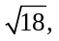 y ∈ R}
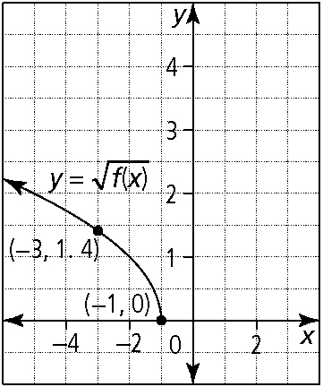
8.

BLM 2–8
(continued)

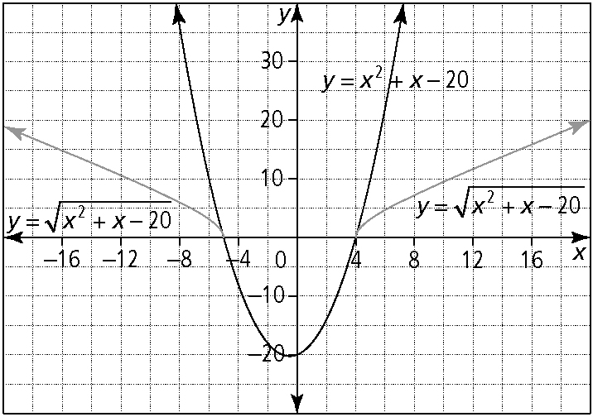
9. a)

b) Example: The graph of y = x² + x − 20 has
y-values that are less than zero for values of x between −5 and 4. Therefore, 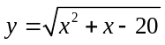 is undefined for this interval of x.
10. a) Example: all points that have a y-value
of 0 or 1
b) Example: all points that have a negative y-value
BLM 2–5 Section 2.3 Extra Practice
1. a) x = 3 b) x = 0 c) no solution d) x = −1
2. Example: In each case, graph the single function and identify the x-intercepts or graph the set of functions and identify the x-value of the point of intersection.
a)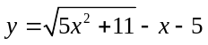 or 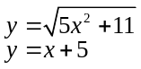
b)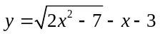 or 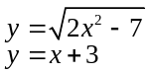
c)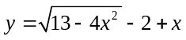 or 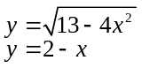
d)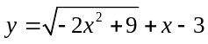 or 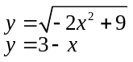
3. a) x = 4 and x = −4 b) x = −9 c) x = 2 and x = −7
d) x = −3
4. a) x = 4 b) no solution c) x = 6 d) x = 26
5. a) x = 2 b) x = 12 c) x = 5 d) x = 6
6. a) x = 4.6 b) x = 3.6 c) x = −5.5 d) x = 9.8
7. a) graphical approach:
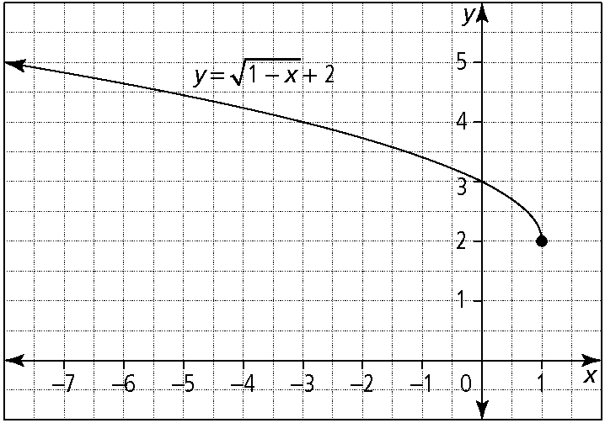
algebraic approach:
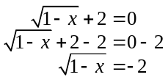
This result is not possible because a square root cannot equal a negative value.
b) Example: Yes; isolate the radical. If it is equal to a negative value, then the equation has no solution.
8. 11 m
9. a) 3.7 cm b) 137 cm²
10. x = 3
BLM 2–7 Chapter 2 Test
1. A
2. B
3. B
4. D
5. B
6. (8, −y + 3) or (8, 1)
7. (−5, 0), (5, 0)
8. 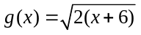
9. a)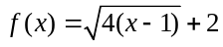 b)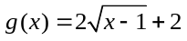
10. a) vertical stretch by a factor of 2 about the
x-axis, translation down 4 units, translation right
3 units
b) domain: 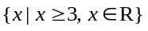;
range: 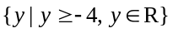
c) The solutions to 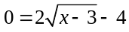 are the
x-intercepts of the graph of 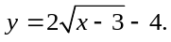

BLM 2–8
(continued)

11. 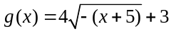
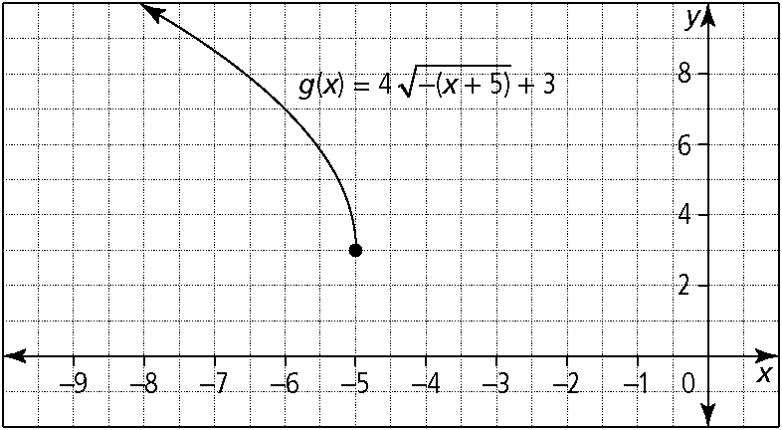
12.
13. a) x = 3 b) Example: Since Mary used an algebraic method, she must verify her answers. Only x = 3 is a solution. John determined the point of intersection, but only the x-coordinate of the point of intersection is the solution.
14. a) x = 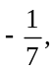 x = 1 b) There are no restrictions on the variable.
15. 83.2 m

