Mathematics 3200 Unit 5: Trigonometric Functions and Graphs(V2)
Name:_________________________
Part A: Selected Response: Circle the letter of the correct response.
1. What is the period of 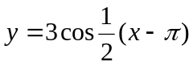?
(A) 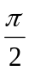 (B) (C) 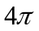 (D) 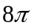
2. What is the range of the function 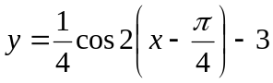?
(A) 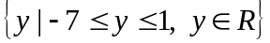 (B) 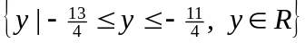
(C) 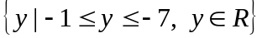 (D) 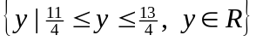

3. What are the transformation of the graph 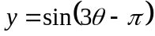?
(A) horizontal stretch by a factor of and a horizontal shift of units right
(B) horizontal stretch by a factor of and a horizontal shift of units right
(C) horizontal stretch by a factor of and a horizontal shift of units right
(D) horizontal stretch by a factor of and a horizontal shift of units right
4. Solve for x: 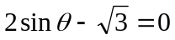 where 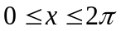
(A) 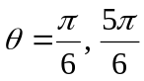 (B) 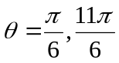 (C) 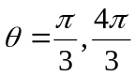 (D) 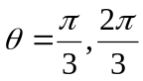
5. What is the vertical displacement of 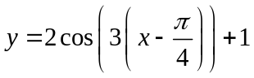?
(A) 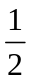 (B) 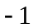 (C) 1 (D)
6. Which graph has the same y-intercept as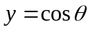?
(A) 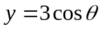 (B) 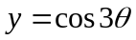 (C) 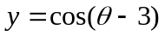 (D) 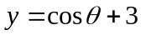

7. The range of a trigonometric function of the form 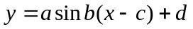is 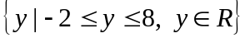. What is the value of d?
(A) 1 (B) 3 (C) 5 (D) 8
8. What is the maximum value of 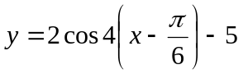?
(A) -7 (B) -3 (C) 3 (D) 7

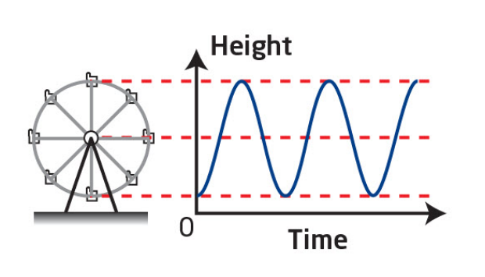9. A Ferris wheel with a radius of 4m rotates once every 20 seconds. Passengers get on board at a point 1m above the ground at the bottom of the Ferris wheel. Which function models this situation?
(A) 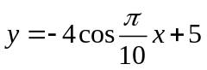 (B) 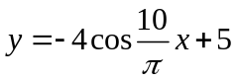
(C) 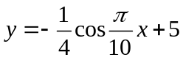 (D) 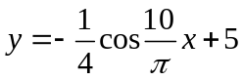

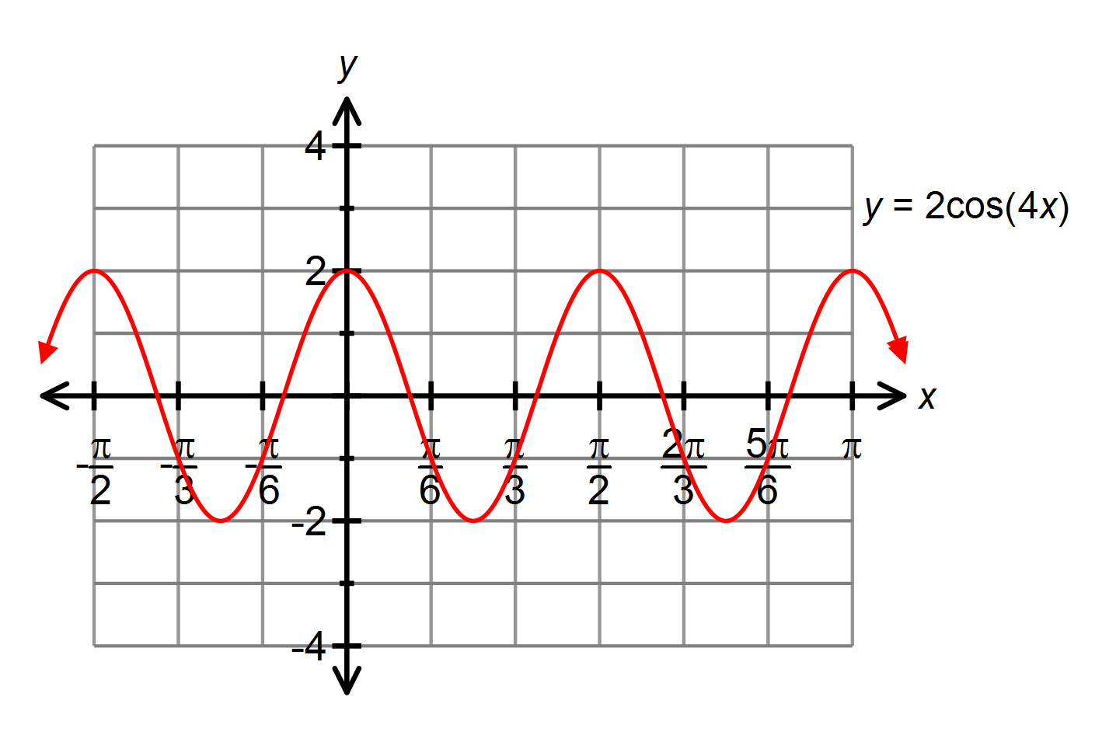10. Given the graph below, what is the solution for 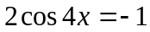 where 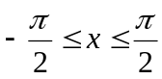?

(A) 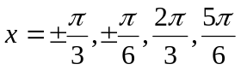
(B) 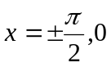
(C) 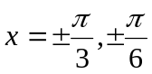
(D) 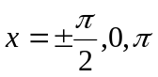

Part B: Constructed Response: Show workings to all problems.
/4 11. Write the equation for the graph shown in the form and in the form 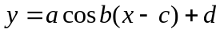.
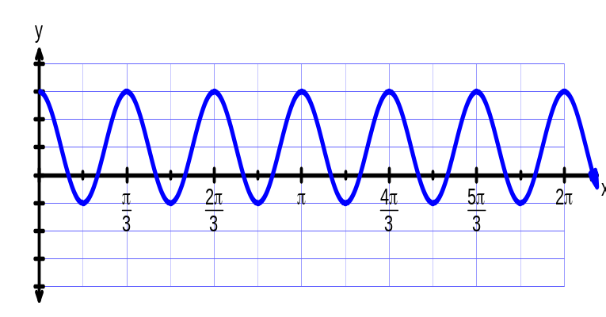

/4 12. Determine all solutions, in radian measure, for the equation 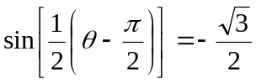

/4 13. Sketch the graph of the function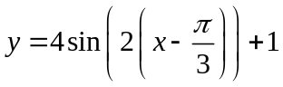.Include a mapping rule and table of values.
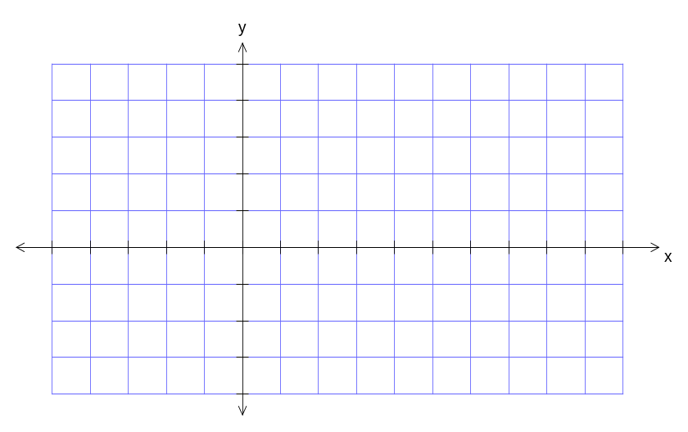

14. In Canada’s wonderland there is a roller coaster that is a continuous series of identical hills that are 16 m high from the ground. The platform to get on the ride is on top of the first hill. If it
takes 3 seconds for the coaster to reach the bottom of the hill 2m off the ground find the sinusoidal equation that best reflects this roller coasters motion? Include an accurate sketch. /4

