**Part A:** Place the letter of the correct response in the space provide (12 marks).

1. What is the remainder when  is divided by ? 1. ____

(A) -15 (B) -13

(C) 1 (D) 25

2. What is the degree of the polynomial $\left(x\right)=x{\left(x-5\right)}^{2}\left(x+3\right)$? 2.____

(A) 2 (B) 3

(C) 4 (D) 5

3. If  is a factor of , what is the value of k? 3.____

(A)  (B) 

(C)  (D) 

4. Which interval describes where the function is positive? 4.____

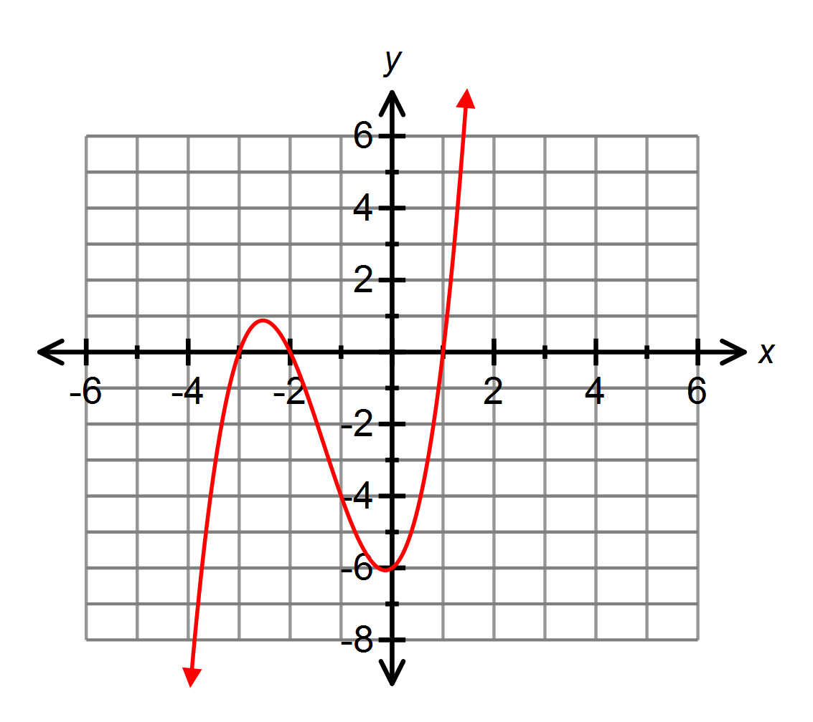

(A) and 

(B)  and 

(C)  and 

(D)  and 

5. What is the end behavior of the polynomial ? 5.___

(A) Quadrant I to Quadrant II  
(B)Quadrant III to Quadrant IV(C) Quadrant I to Quadrant III(D) Quadrant II to Quadrant IV

6. The graph of a third degree polynomial function of the form P(x) = ax3 + bx2 + cx + d is shown. Which statement about the values of *a* and *d* is correct? 6.____



(A) *a* > 0 and *d* > 0

(B) *a* > 0 and *d* < 0

(C) *a* < 0 and *d* > 0

(D) *a* < 0 and *d* < 0

7. Which polynomial function has zeros of -2, 1(multiplicity 2), 3 and 7.____  
*y*-intercept = -6?

(A)    
 (B)   
 (C)   
 (D) 



8. Which function represents the graph? 8.____

(A) P(x) = (x – 2)2(x + 1)

(B) P(x) = –(x – 2)2(x + 1)

(C) P(x) = (x + 2)2(x – 1)

(D) P(x) = –(x + 2)2(x – 1)

9. When a polynomial *P*(*x*) is divided by x – 2, the quotient is  and 9.____  
the remainder is -4. What is the polynomial?

(A)   
(B)   
(C)   
(D) 

10. Which graph represents a quintic polynomial function with a negative leading coefficient and zeros with multiplicity 2 and 3? 10.____



(A) (B)



(C) (D)

11. What is the remainder when $P\left(x\right)=-2x^{81}+3$ is divided by $(x-1)$? 11.___

(A) 1 (B) 0

(C) 3 (D) 5

12. Which represents $x^{3}+2x^{2}-9x-18$ when it is completely factored? 12.___

(A) $\left(x^{2}-9\right)(x+2)$ (B) $\left(x-3\right)\left(x-3\right)(x+2)$

(C) $\left(x-3\right)(x+3)(x+2)$ (D) $\left(x^{2}+9\right)(x-2)$

**Part B: Constructed Response:** Show workings to all problems.

13. Determine the zeros and sketch the graph for the polynomial. (6 marks)



14. Determine the equation of the function in factored form. (4)

15. When  is divided by *x* – 2, the remainder is 1. Determine the value(s) for *k.* (3 marks)

**16.** A toothpaste box has square ends. The length of the box is 12 cm greater than the

width. The volume is 135 cm3. What are the dimensions of the box? (4)