BLM 4–9
Chapter 4 BLM Answers

BLM 4–1 Chapter 5 Prerequisite Skills
1. Estimates will vary. Actual measurements are
as follows:
a) 52° b) 138° c) 334°
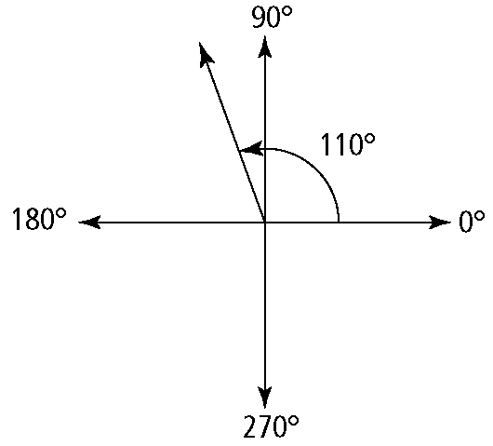
2. a)

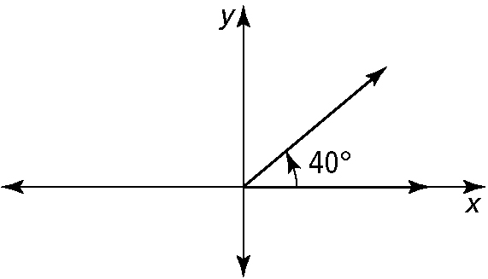
b)

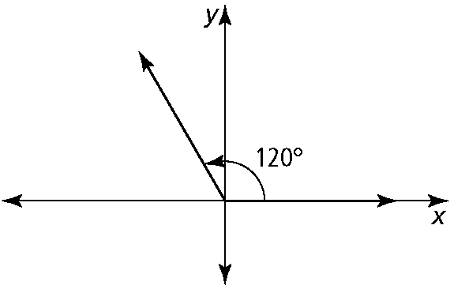
c)

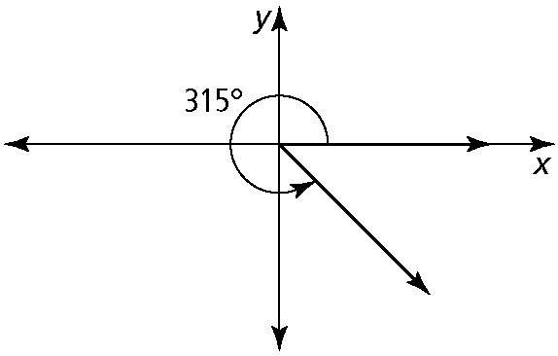
d)

3. a) IV b) II c) I d) III e) IV f ) II
4. a) 40° b) 40° c) 80° d) 85° e) 50.6° f ) 6°
5. a) 12 756π; 40 074.2 km b) 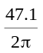; 7.5 mm
c) C = 23.25π; 73.0 in.
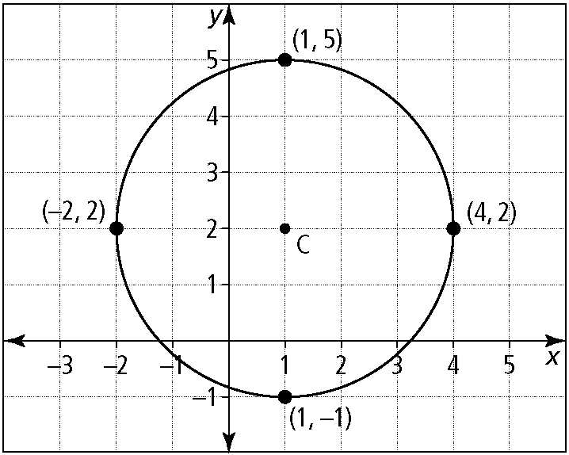
6.

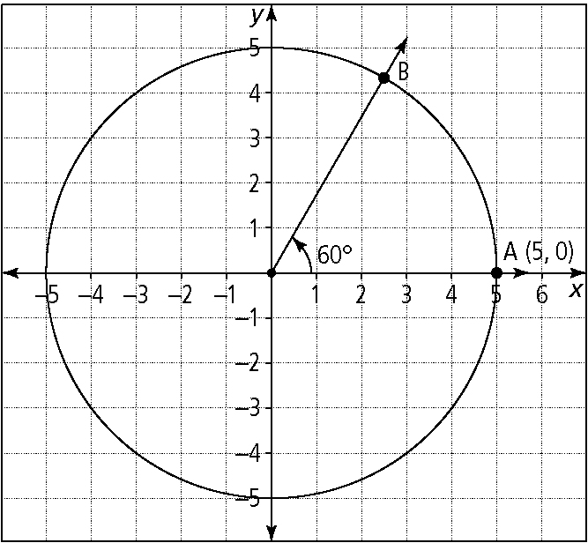
7. a)

b)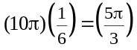 c) 5.2 units
8. a)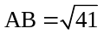 b) 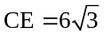 c) FG = 2
9. a) 322° b) 252.5° c) 169° d) 132.9°
10. 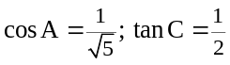 b) 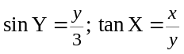
11. a) 0.59 b) 0.05 c) −0.58
d) −0.99 e) 19.08 f) −0.97
12. a) 6y (x − 2y)(x + 2y) b) (x − 10)(x − 1)
c) 3(2x − 1)(x − 3) d) (3x + 2)(2x − 5)
13. a) x = ±3 b) 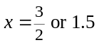
c) y = −10 or 3 d) 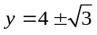
14. 31.95 cm

BLM 4–9
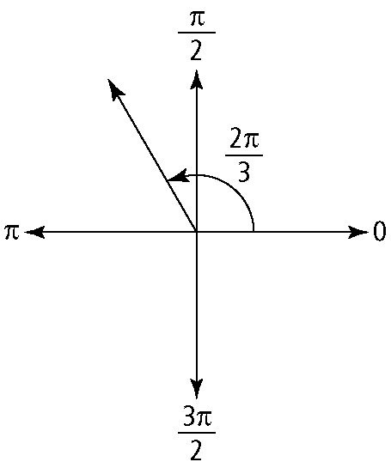
(continued)

BLM 4–2 Section 4.1 Extra Practice
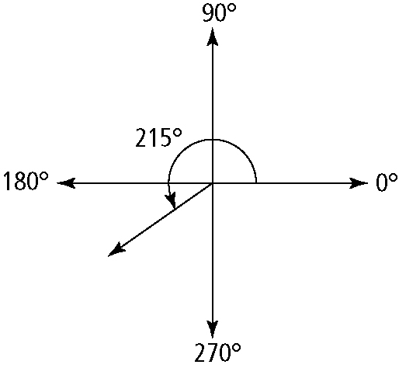
1. a)

quadrant III
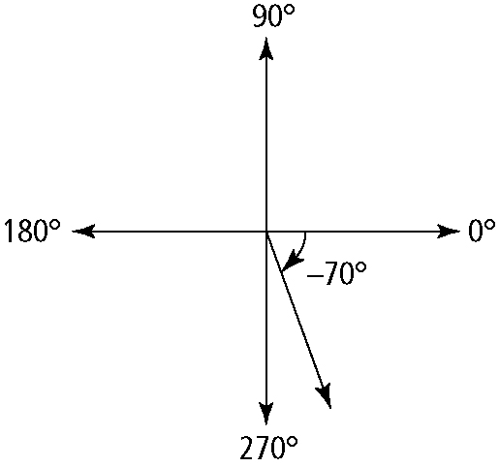
b)

quadrant IV

c)

quadrant II
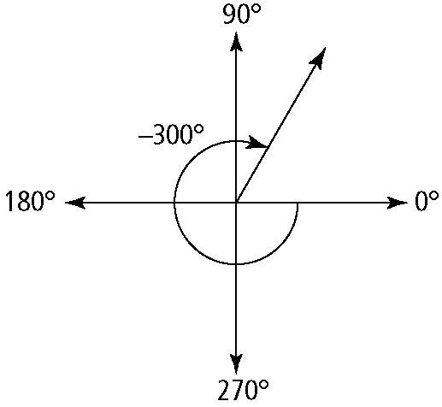
d)

quadrant I
2. a)

quadrant II
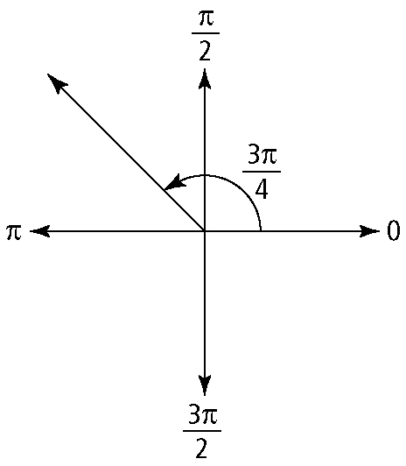
b)

quadrant II
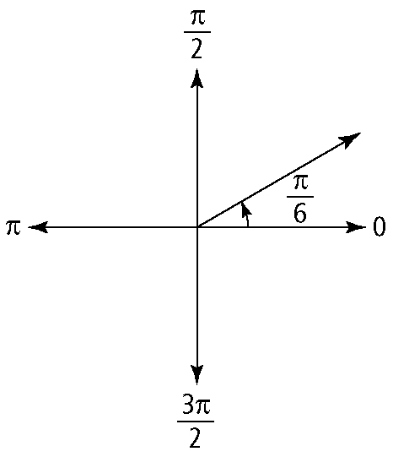
c)

quadrant I

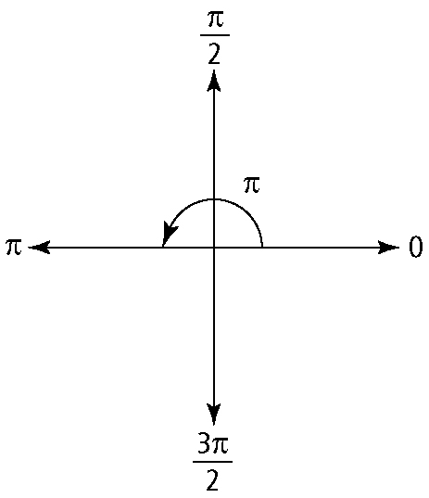
d)

no quadrant

BLM 4–9
(continued)

3. a) 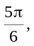2.62 b) 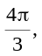 4.19
c) 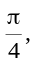0.79 d) 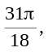5.41
4. a) 144° b) 150° c) 123.75° d) −315°
5. a) 183° b) 229° c) 344° d) −143°
6. a) 810°, 1170° b) 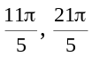 c) 7.98, 14.27
7. a) subtract 360°
b) subtract 2π, and use fractions to determine the exact value
c) subtract 2π using your calculator, and then round your answer to the required accuracy
8. a) 75º ± (360º)n, where n is a natural number
b) 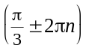radians, where n is a natural number
c) (1 ± 2πn) radians, where n is a natural number
9. 20.9 cm
10. 1.43 radians
BLM 4–3 Section 4.2 Extra Practice
1. a) x² + y² = 16 b) x² + y² = 5
c) x² + y² = 82.81 d) x² + y² = 121
2. 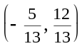 and 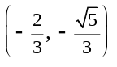; When the coordinates are substituted into x² + y² = 1,
the LHS equals the RHS.
3. a) 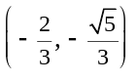 b) 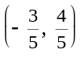
c) 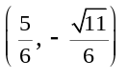 d) 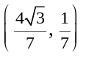
4. a) 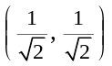 b) (0, −1)
c) 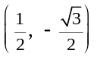 d) 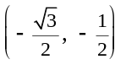
5. a) 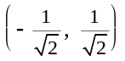 b) 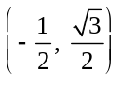
c) (1, 0) d) 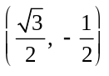
6. a) 225° b) 180° c) 315° d) 240°
7. a) 0π b) 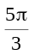 c) 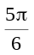 d) π
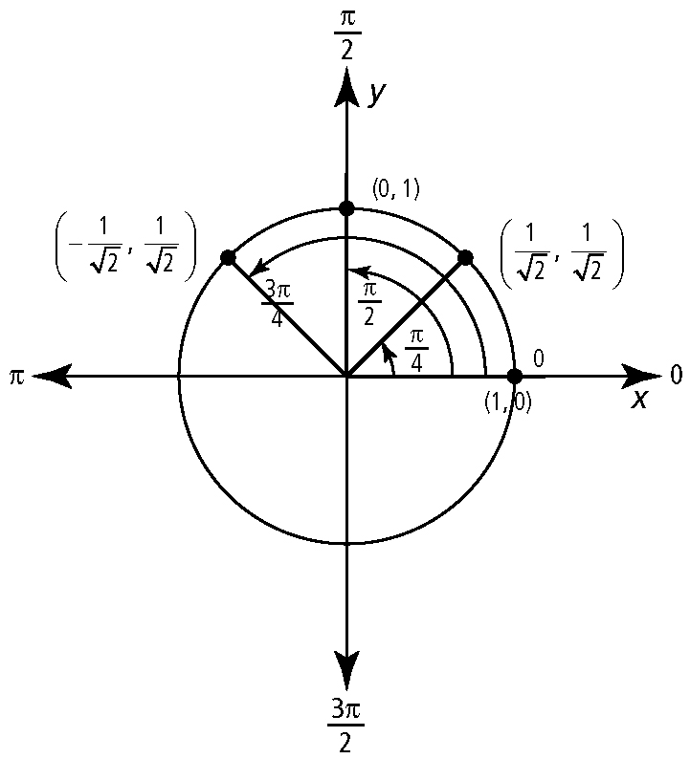
8.

9. a) 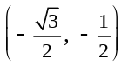 b) 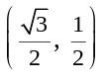
10. a) 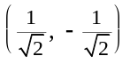 b) 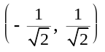
BLM 4–5 Section 4.3 Extra Practice
1. a) b) 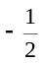 c) −1 d) −1 e) 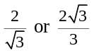 f ) −1
2. a) 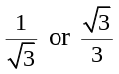 b) c) −1 d) −1
e) 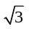 f )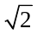
3. a) 0.64 b) −0.82 c) −2.36 d) −1.19
4. a) −1.25 b) −0.73 c) 1.03 d) 0.68
5. a) II or III b) I or II c) I or III
d) IV e) IV f ) II
6. a) −sin 50° b) cos 50° c) −tan 80°
d) −csc 80° e) cot 20° f ) sec 70°
7. a) 135°, 315° b) −30°, 30°
c) 30° d) −270°, −90°, 90°, −270°
8. a) 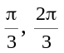 b) −π, π c) 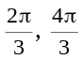 d) 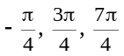
9. a) two solutions; 0.43, 2.71
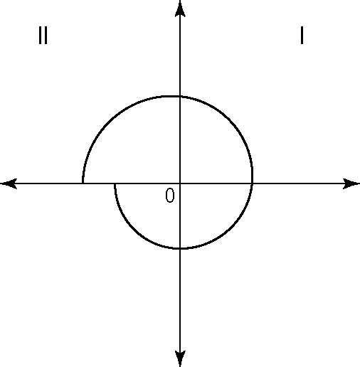

BLM 4–9
(continued)

b) two solutions: –2.03, 2.94
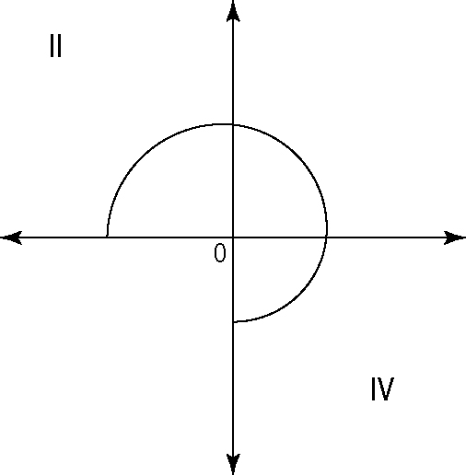
c) three solutions: –281.85°, –78.15°, 78.15°
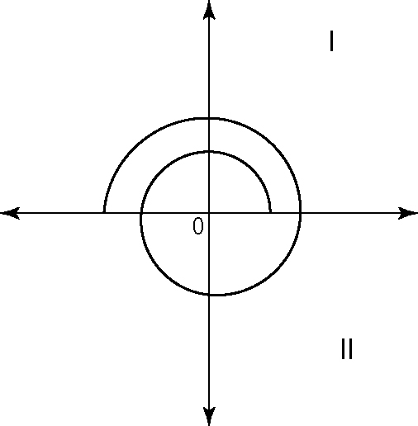
d) three solutions: –123.69°, 56.31°, 236.31°
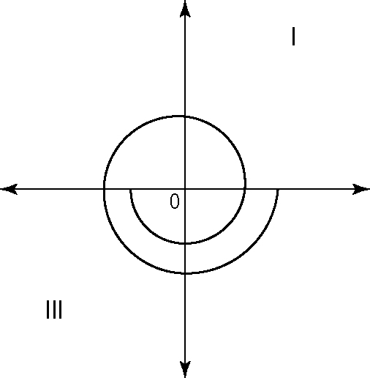

10. 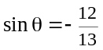 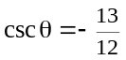
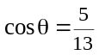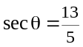
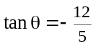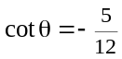
BLM 4–6 Section 4.4 Extra Practice
1. a) 60°, 300° b) 120°, 300°
c) 30°, 150° d) 120°, 240°
2. a) 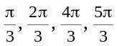 b)
c) 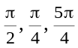 d) 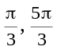
3. a) b) 0, c) 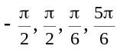
4. a) 1.35, 4.49 b) 1.76, 4.90
c) 1.14, 2.00 d) 0.08, 3.22

5. | LS | RS |  | LS | RS
 | sin² θ − 1 | 0 |  | sin² θ − 1 | 0
 | =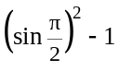 |  |  | =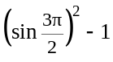
 | = (1)² − 1 |  |  | = (–1)² − 1
 | = 0 |  |  | = 0
6. No. Example: The range of the cosine function is [−1, 1]. Cosine is undefined for values that are outside of this range.
7. a) 0.7854, 2.1910, 3.9270, 5.3326
b) 1.1071, 1.240, 4.2487, 4.3906
c) 0, 1.3258, 4.4674
8. 2πn, 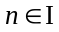
9. 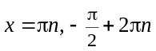
10. 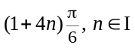
BLM 4–8 Chapter 4 Test
1. C
2. A
3. A
4. C
5. D
6. a) Example: unitary method; 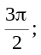 ≈ 4.71
b) Example: proportion method; −3π; ≈ −9.42
c) Example: unit analysis; 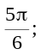 ≈ 2.62
d) Example: unitary method; 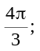 ≈ 4.19

7. a) Example: proportion method; ≈ 186.21°
b) Example: unitary method; ≈ 22.92°
c) Example: unit analysis; −315°
d) Example proportion method; ≈ −306.53°
8. 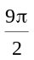
9. a) θ ≈ 133.69° or 2.33 b) a ≈ 31.85 cm
c) r ≈ 6.99 m d) a ≈ 4.28 ft
10. 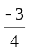
11. 0.6
12. 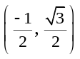, 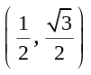
13. 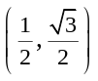

BLM 4–9
(continued)

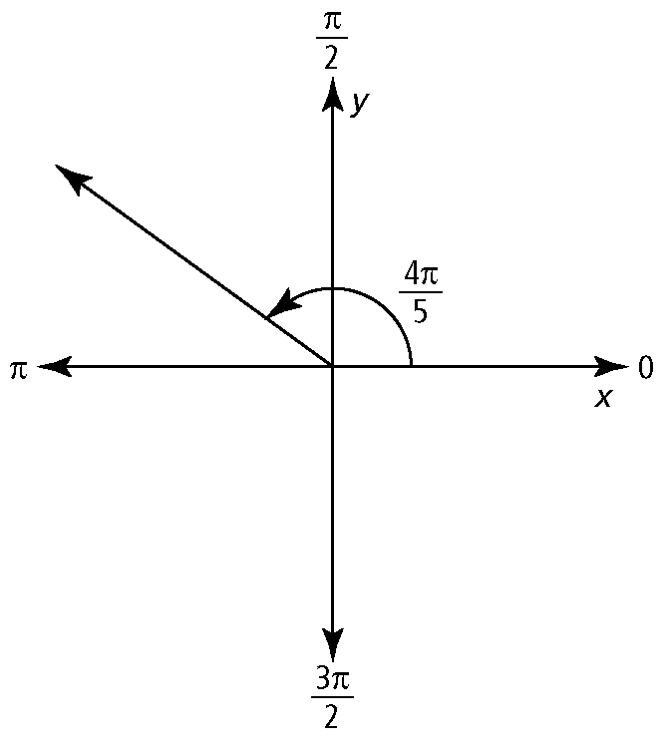
14. a)

b) 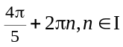
15. sin θ = 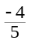, cos θ = , tan θ = 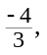
csc θ = 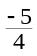, sec θ = , cot θ = 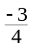
16. 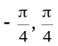
17. a) Equation A: 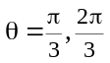; Equation B: 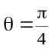
b) Equation C is the product of Equation A times Equation B (i.e., AB = C). Therefore, the solution to Equation C is the solutions to A and B: 

