Math 3201 Unit 1 Review
1) Consider the sets:
A={1, 3, 4, 7, 8, 9}
B={1, 2, 3, 4,5}
C={1, 3}
- Are any of these sets disjoint? Explain.
- Identify any subsets.
- What is A intersect B $(A∩B)$?
- What is A union B $(A∪B)$?
- Identify $n(A∩B)$, and $n(A∪B)$.
2) Consider the sets:
A={1, 2}
B={4, 5, 6}
C={5, 6, 7, 8}
Are any of these sets disjoint? Explain.
3) Consider the sets:
U={1, 2, 3, 4, 5, 6, 7, 8, 9} A={1, 3, 5, 7, 9} B={2, 4, 6}
- Determine A’
- Determine B’
4) At the beach one afternoon, Carrie collected the items defined by the set
A={conch shell, sand dollar, starfish}. Michael collected the items defined by the set B={sand, seaweed, clamshell}. Find A intersect B.
5) Describe what the shaded region represents:
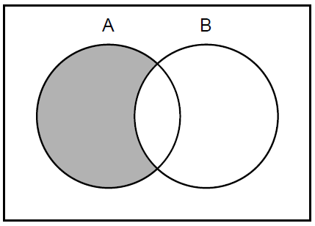
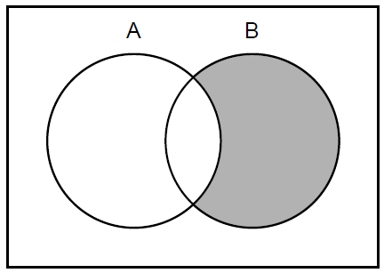
(a) (b)

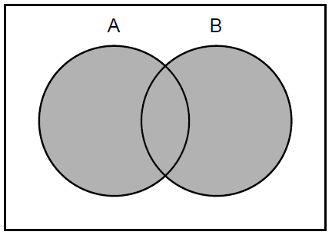
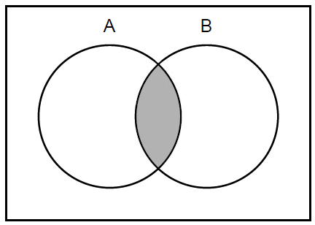
(c) (d)

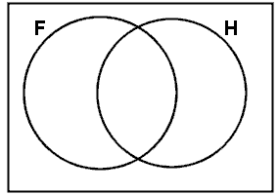6) In a class there are:
- 8 students who play football and hockey
- 7 students who do not play football or hockey
- 13 students who play hockey
- 19 students who play football
How many students are in the class?

7) In a class there are 30 students.
- 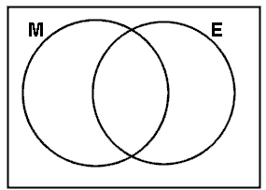21 students like Math
- 16 students like English
- 6 students don't like Math or English
How many students like both Math and English?

8) The diagrams below represent a class of children.
G is the set of girls and F is the set of children who like football.

Decide which diagram represents:
- Girls who like football
- Girls who dislike football
- Boys who like football
- Boys who dislike football
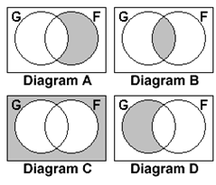
9) In a school canteen there are 45 children. Today’s menu includes:
- Fish
- Chips (French Fries)
There are 16 who have finished eating.
There are 26 eating chips (French fries) and 17 eating fish.
How many students are eating fish and chips?
How many students are eating only chips?
10) In a class of 50 students, 18 take Chorus, 26 take Band, and 2 take both Chorus and Band. How many students in the class are not enrolled in either Chorus or Band?
11) The freshman science classes were surveyed to see whether they wanted to visit the local natural history museum or a nearby state park. They could choose the museum, the park, both, or neither. The results of the survey are shown in the Venn diagram below. If 96 students were surveyed, how many wanted to go to the state park only?
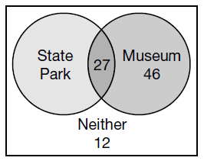

12) In a school of 320 students, 85 students are in the band, 200 students are on sports teams, and 60 students participate in both activities. How many students are involved in either band or sports? How many students are not involved with either?
13) The diagrams below represent the activities chosen by youth club. They can choose to play Tennis (T), Badminton (B) or squash (S)
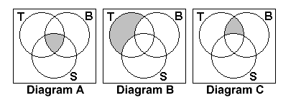
Which diagram represents:
(a) those who play all three sports.
(b) those who play tennis and badminton, but not squash.
(c) those who play only tennis
14) The Venn diagram at the right shows the three types of food ingredients students picked as things they like in dessert: nuts, fruit, and chocolate
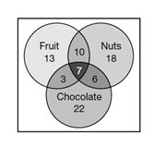
- How many students like desserts with nuts and chocolate?
- How many students would like a combination of all three ingredients in a dessert?
- How many students like only desserts with nuts?
- How many students like desserts with fruit and nuts but no chocolate?
- How many students were polled in the survey?
15) Use the Venn Diagram below to answer the questions which follow:
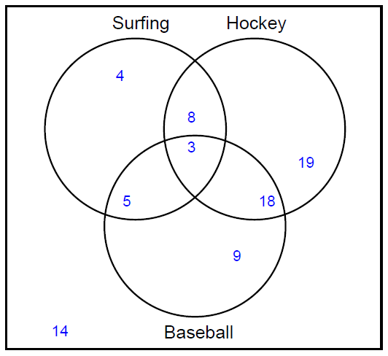
- How many students like Surfing or Hockey or Baseball?
- How many students like only baseball?
- How many student do not like either surfing or hockey?
- How many students do not like either surfing or baseball?
- How many students like both surfing and hockey?
- How many students do not like both hokey and baseball?
- How many students like surfing or baseball?
- How many students like both hockey and baseball but not surfing?
- How many students like surfing or baseball but not hockey?

16) All the members of a group of 30 teenagers belong to at least one club. There are 3 clubs: chess, drama and art.
- 6 of the teenagers belong to only the art club.
- 5 of the teenagers belong to all 3 clubs.
- 2 of the teenagers belong to the chess and art clubs but not to the drama club.
- 15 of the teenagers belong to the art club.
- 2 of the teenagers belong only to the chess club.
- 3 of the teenagers belong only to the drama club.
(a) How many of the group do chess and drama but not art?
- How many of the group belong to the chess club?

17) In a class of 32 pupils:

- 5 pupils live in New Town, travel to school by bus and eat school dinners
- 3 pupils live in New Town, travel to school by bus but do not eat school dinners
- 9 pupils do not live in New Town, do not travel to school by bus and do not eat school dinners
- 11 pupils live in New Town and have school dinners
- 16 pupils live in New Town
- 9 pupils travel by bus and eat school dinners
- 13 pupils travel by bus
How many pupils eat school dinners?

18) A veterinarian surveys 26 of his patrons. He discovers that 14 have dogs, 10 have cats, and 5 have fish. Four have dogs and cats, 3 have dogs and fish, and one has a cat and fish. If no one has all three kinds of pets, how many patrons have none of these pets?
19) A guidance counselor is planning schedules for 30 students. Sixteen students say they want to take French, 16 want to take Spanish, and 11 want to take Latin. Five say they want to take both French and Latin, and of these, 3 wanted to take Spanish as well. Five want only Latin, and 8 want only Spanish. How many students want French only?
20) 70 students were surveyed to determine their travel interests.
10 students wanted to go to all three destinations.
18 students wanted to go to Paris and Spain
16 students wanted to go to New York and Paris
44 students wanted to go to Paris
27 students wanted to go to New York.
32 students wanted to go to Spain.
4 students did not want to go to either of these locations
How many students wanted to go to New York and Spain but not Paris?

21) A survey of 120 first-graders was conducted concerning the types of animals that were in the last book each of them read. The following results were obtained:
- 48 read about an elephant
- 56 read about a monkey
- 44 read about a tiger
- 7 read about an elephant and a tiger but not a monkey
- 13 read about an elephant and a monkey but not a tiger
- 14 read about a monkey and a tiger but not an elephant
- 18 students did not read about any of these animals.
How many students read a book about all three animals?
22) Consider the following sets:
$S=\left\{s|s=2x,-1≤x≤4,x∈I\right\}$
C={c|$c=5x,-2≤x≤4,x∈I\}$
- List the elements of each set.
- What is S union C $(S∪C)$?
- What is S intersect C $(S∩C)$?

