**Math 1201- Answer Key – June 2013**

**Part II**

**Total Value: 60%**

value

3 41. A right square pyramid has side length 36 cm and slant height 30 cm. What is the volume of the pyramid to the nearest cm3.

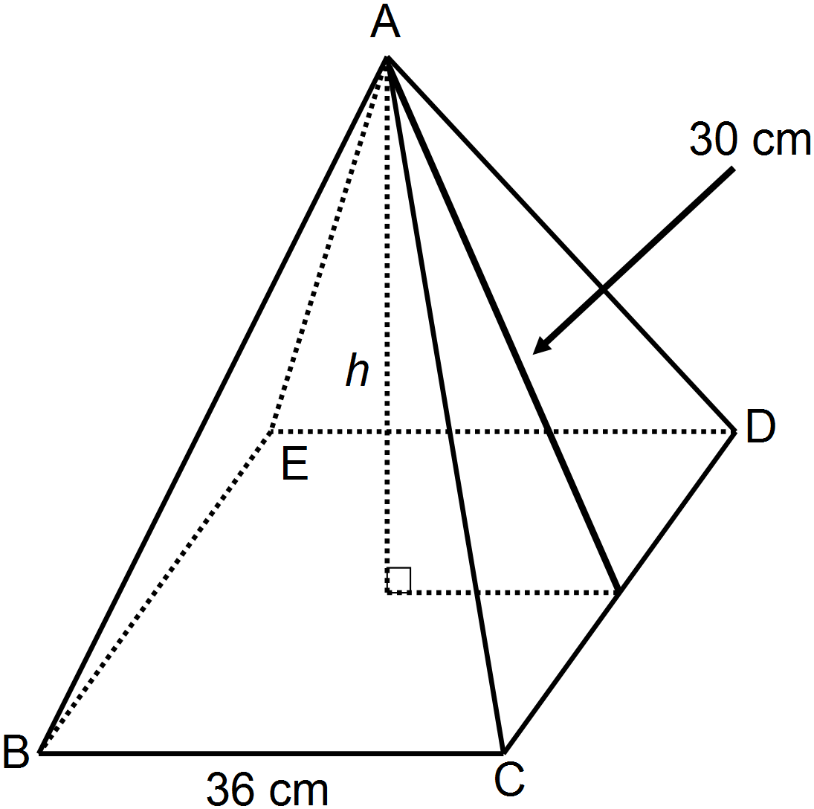

|  |
| --- |
| **Height of Pyramid ${18}^{2}+ h^{2} = {30}^{2}$**  0.5 mark $$h^{2} = 900-324$$ $$h^{2} = 576$$ $$h= \sqrt{576}$$ $h=$ $24$ 1 mark  **Volume $$V= \frac{1}{3}lwh$$ $V= \frac{1}{3}(36)(36)(24)$**  0.5 marks $V= \frac{1}{3}(31104)$ 0.5 mark $V=10368 {cm}^{3}$ 0.5 mark |

2 42. The surface area of a sphere is 804.2 in2. What is the radius of the sphere?.



|  |
| --- |
| $$Surface Area=4πr^{2}$$ $$804.2= 4πr^{2}$$ $804.2=4\left(3.14\right)r^{2}$ 0.5 mark $804.2= 12.56r^{2}$ 0.5 mark $64.03 =r^{2}$ 0.5 mark $\sqrt{64.03}=r$ $r=8$  in 0.5 mark  The radius is 8 inches in length. |

4 43. Joe made a wooden scratching post for his cat and wants to cover it with carpet. About how much carpet will he need if he covers everything except the bottom of the square block?

|  |
| --- |
| **Surface Area of Cylinder $SA=2πr^{2}+ 2πrh$ $$SA=2(3.14){\left(6\right)}^{2}+2(3.14)(6)(24)$$ $$SA=226.08+904.32$$ $SA=1130.40 {cm}^{2}$**    1 mark  **Surface Area of Rectangular Prism $$A_{sides}=lw$$ $$A_{sides}=\left(30\right)\left(10\right)×4 sides$$ $$A_{sides}=300 × 4 sides$$ $A_{sides}=1200 {cm}^{2}$**  1 mark $$A_{top}=(30)(30)$$ $A_{top}=900 {cm}^{2}$ 0.5 mark $$A_{overlap}= 2πr^{2}$$ $$A_{overlap}= 2(3.14)6^{2}$$ $A_{overlap}= 226.08 {cm}^{2}$ 1 mark $$Total SA= A_{cylinder}+ A_{rectangular prism}- A_{overlap}$$ $$Total SA=1130.4 {cm}^{2}+2100 {cm}^{2}-226.08 {cm}^{2}$$ $Total SA=3004.32 {cm}^{2}$ 0.5 mark |

4 44. Solve $∆CAT$. Give all measurements to the nearest tenth.

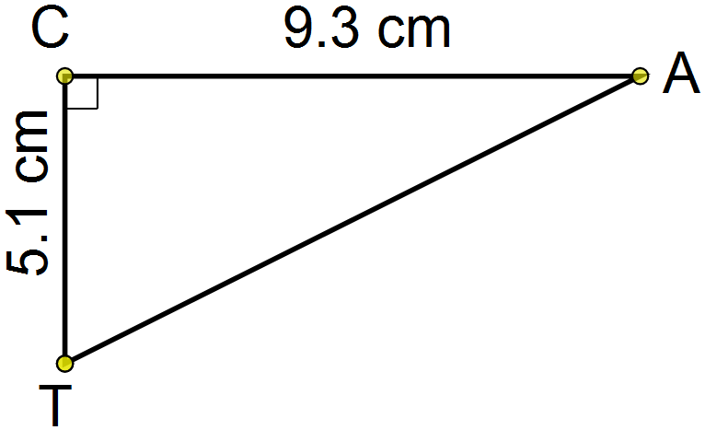

|  |  |
| --- | --- |
| **Sample Solution**  **Find hypotenuse $$l^{2}+l^{2}=h^{2}$$ $${(5.1)}^{2}+{(9.3)}^{2}=h^{2}$$ $26.01+86.49= h^{2}$ $$112.5= h^{2}$$ $$h= \sqrt{112.5}$$ $h ≐10.6 cm$**    1.5 marks | **Find either A orT** |

4 45. At 180 m from shore, some tourists spot a lighthouse from their boat. The angle of elevation to the bottom of the lighthouse is ${26}^{0}$. The angle of elevation to the top of the lighthouse is ${36}^{0}$. What is the height, *h*, of the lighthouse?

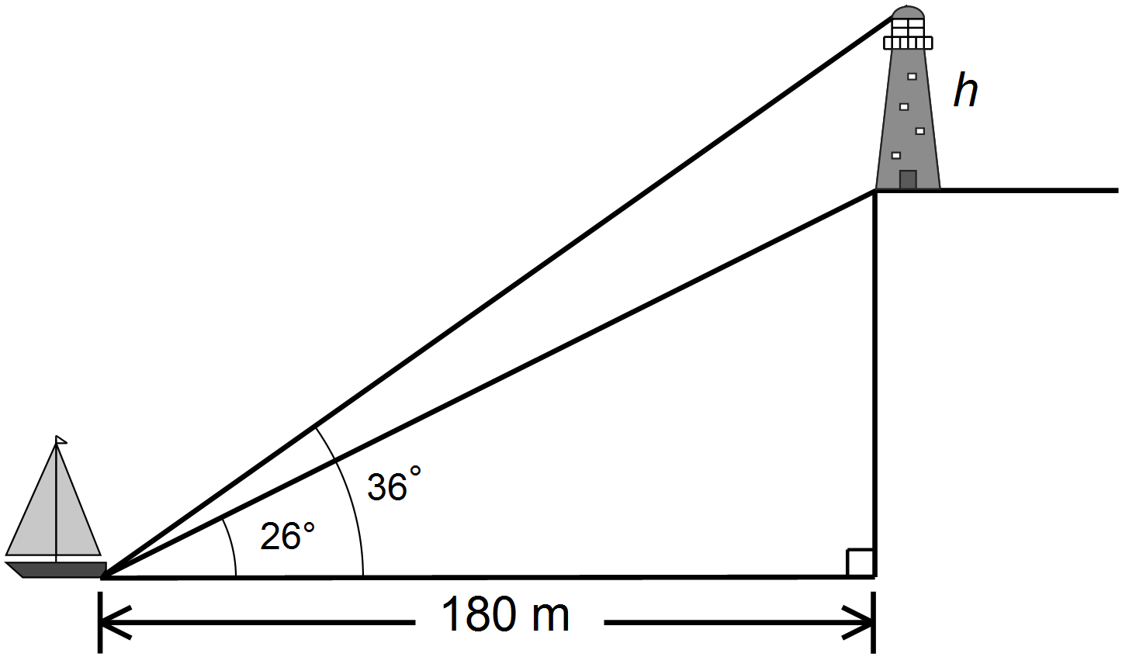

|  |  |
| --- | --- |
|  |  |
|  | |



3 46. Julie completed a math problem and made a mistake. In which step does the first error occur? Rewrite Julie’s solution so that it is correct.

|  |  |  |
| --- | --- | --- |
| The error occurs in step _**2**_ 1 *mark*  Correct solution:   |  | | --- | |  | |  |

3 47. Simplify: (the final answer must contain only positive exponents)

|  |
| --- |
| Sample Solution |

4 48. The surface area of a cube is 96 cm2. Determine the length of the diagonal, *x*, of one of the faces. Express your answer in simplest radical form.

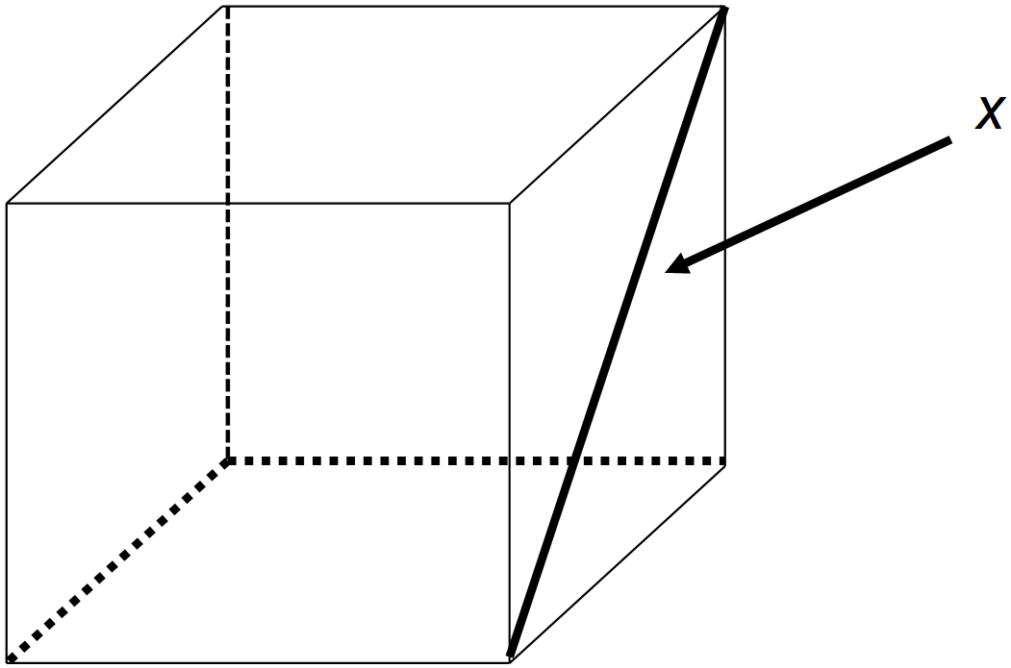

|  |
| --- |
| SA = 96 cm2  1 mark  Let s represent side length $$A=s^{2}$$ $$16 {cm}^{2}=s^{2}$$ $$\sqrt{16}=s$$ $4 =s$ 1 mark $$x^{2}=s^{2}+s^{2}$$ $$x^{2}=4^{2}+4^{2}$$ $$x^{2}=16+16$$ $x^{2}=32$ 1 mark $$x=\sqrt{32}$$ $$x=\sqrt{16 ×2}$$ $x=4\sqrt{2}$ 1 mark |

3 49. Expand and simplify: $(2x-7)(3x^{2}+4x+2)$

|  |
| --- |
| $(2x-7)(3x^{2}+4x+2)$ $6x^{3}+8x^{2}+4x-21x^{2}-28x-14$ 1.5 marks $6x^{3}-13x^{2}-24x-14$ 1.5 marks |

3 50. Factor completely: $4x^{3}+6x^{2}-4x$

|  |
| --- |
| $2x(2x^{2}+3x-2)$ 1 mark $2x(2x^{2}+4x-x-2)$ 0.5 mark $2x[2x\left(x+2\right)-1\left(x+2\right)]$ 1 mark $2x(2x-1)(x+2)$ 0.5 mark |

3 51. The area of a rectangle is represented by the polynomial 8x2 + 10x + 3. If the length of one side is 4x + 3, determine the width of the rectangle.

|  |
| --- |
| Sample Solution $$8x^{2}+10x+3$$ $8x^{2}+4x+6x+3$ 1 mark $4x\left(2x+1\right)+3\left(2x+1\right)$ 1 mark $(4x+3)(2x+1)$ 1 mark |

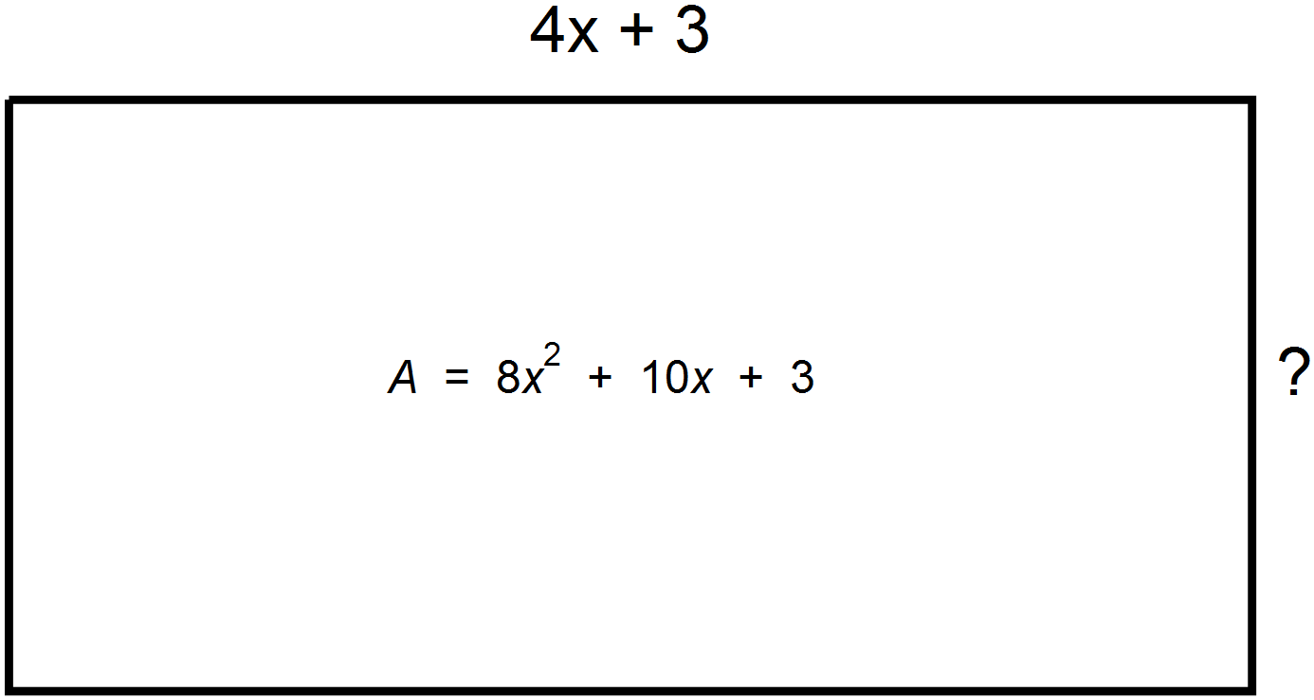

4 52. Valerie plans to put siding on the front of her garage pictured below. Find an expression (in simplest form) to represent the area of the surface to be covered with siding (Note: There will be **NO** siding on the two doors)

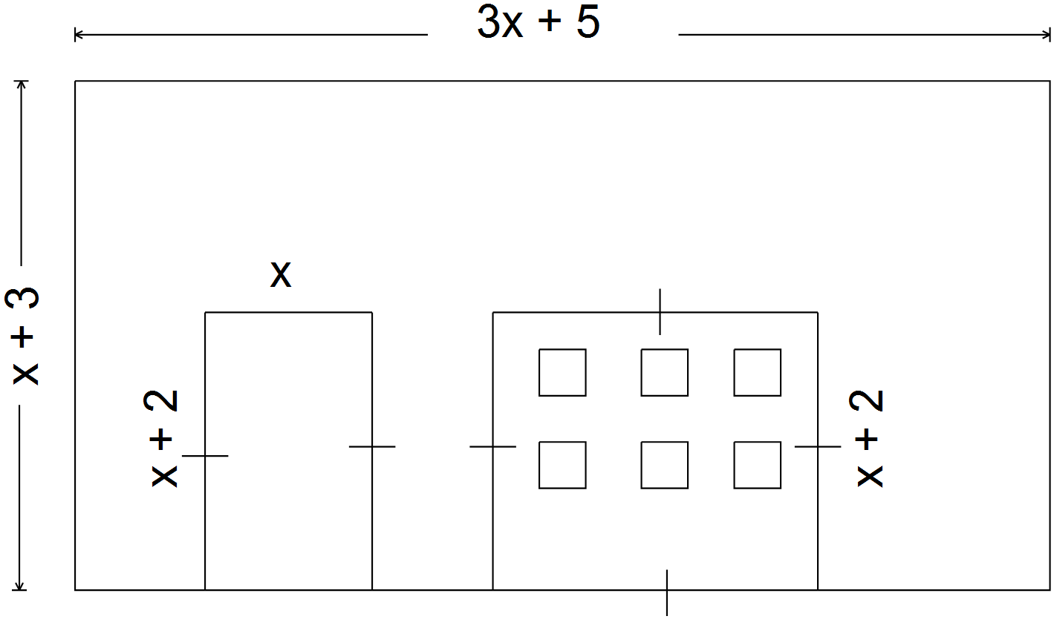

|  |
| --- |
| $$A_{siding}=A_{front}-A_{doors}$$ $$A_{front}=(x+3)(3x+5)$$ $$A_{front}=(3x^{2}+5x+9x+15)$$ $A_{front}=(3x^{2}+14x+15)$ 1 mark $A_{doors}=x\left(x+2\right)+(x+2)(x+2)$ 1 mark $$A_{doors}= x^{2}+2x+x^{2}+2x+2x+4$$ $A_{doors}=2x^{2}+6x+4$ 0.5 mark $A_{siding}=\left(3x^{2}+14x+15\right)-\left(2x^{2}+6x+4\right)$   0.5 mark $$A_{siding}= 3x^{2}+14x+15- 2x^{2}-6x-4$$ $A_{siding}= x^{2}+8x+11$ 1 mark |

4 53. A t-shirt printing company charges $20 for the initial setup of the printing press plus $5 for every t-shirt printed. Illustrate the relationship using each of the four methods requested in the table below. (Note: **n** is the number of

t-shirts and **C** is the cost in dollars)

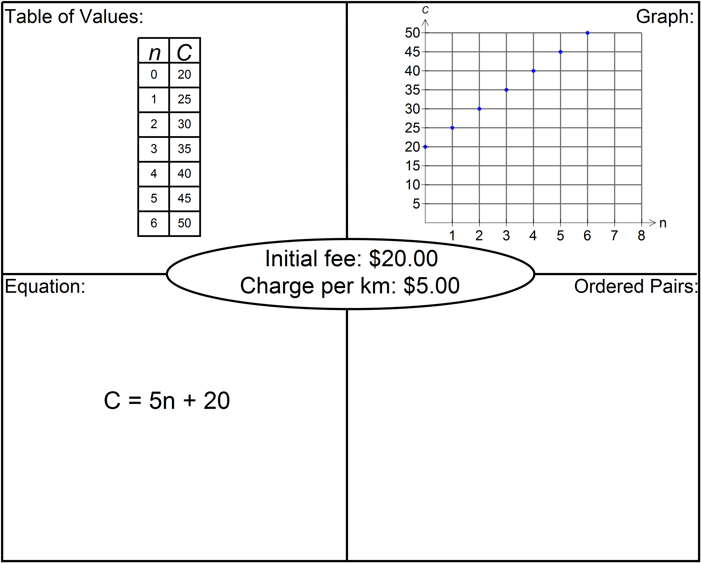

(0, 20) (5, 45)

(1, 25) (6, 50)

(2, 30)

(3, 35)

(4, 40)

3 54. The graph shows Jake leaving home at Point A and travelling by motorcycle to Gros Morne, located at point H.

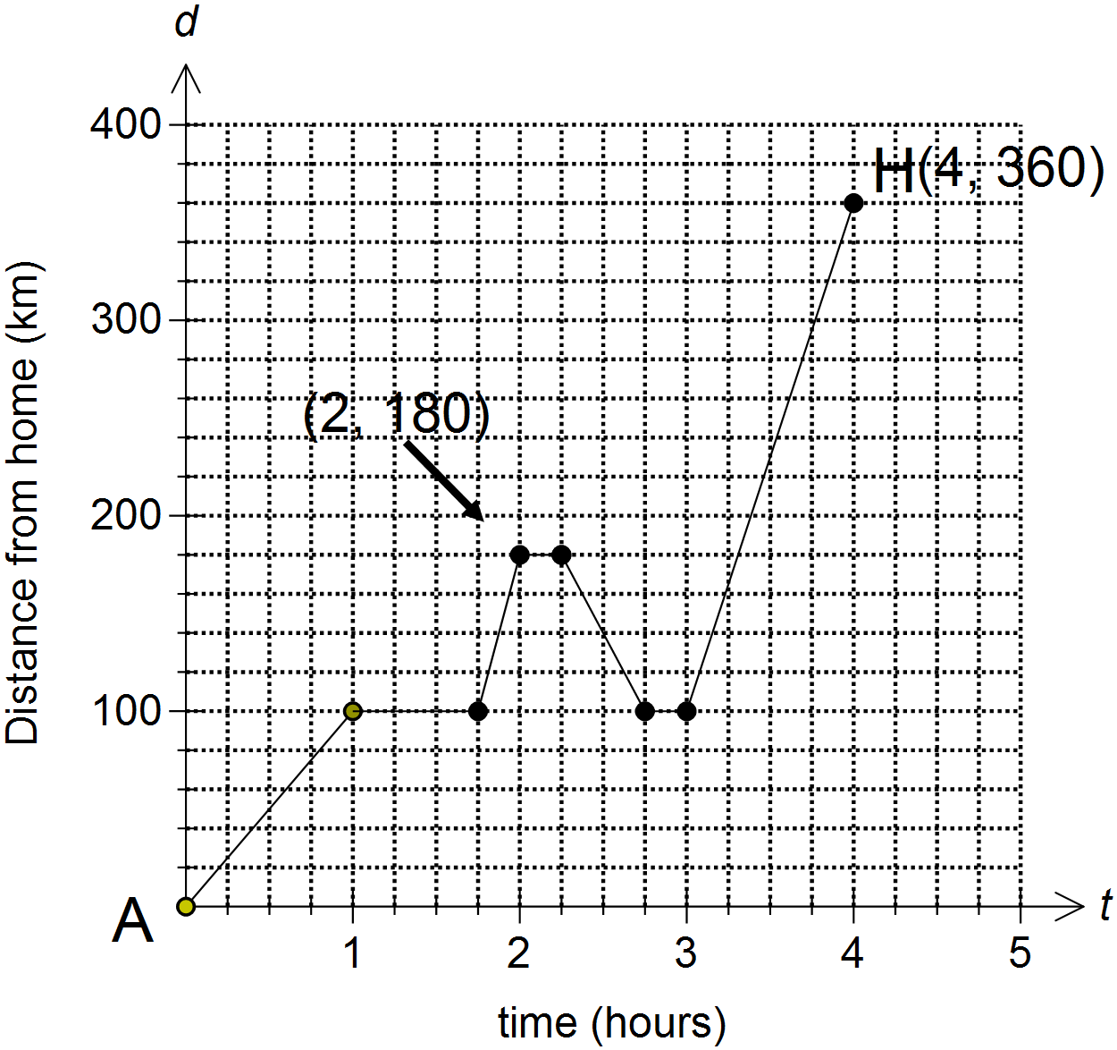

|  |
| --- |
| 1. What was Jake’s maximum rate of change (i.e. speed)?   =**320 km/h**  1 mark   1. From the time he left home, how many times did Jake stop and what was the total minutes stopped?   Jake stopped **3** times 0.5 mark    He was stopped for a total of **75** minutes 0.5 mark   1. How many kilometres did Jake put on his motorcycle from the time he left home (at point A) until he arrived at Gros Morne (point H)? **520 km** 1 mark |

3 55. A line passes through the points $(6, 4)$ and $(2, -6)$. Determine the equation of the line in slope-intercept form $y=mx+b$

|  |  |
| --- | --- |
| $$m=\frac{y_{2}-y_{1}}{x_{2}-x_{1}}$$ $m=\frac{-6-4}{2-6}$ 0.5 mark $m=\frac{-10}{-4}$ $m= \frac{5}{2}$  0.5 mark | $$y=\frac{5}{2}x-11$$ $4=\frac{5}{2}\left(6\right)+b$ 0.5 mark $$4=\frac{30}{2}+b$$ $$4=15+b$$ $-11=b$ 1 mark |
| $y=\frac{5}{2}x-11$ 0.5 mark | |

4 56. Determine the equation of the line that passes through $(10, -4)$ and is perpendicular to the line $7x-14y+28=0.$

|  |
| --- |
| $$7x-14y+28=0$$ $-14y=-7x-28$ 0.5 mark $$\frac{-14y}{-14}=\frac{-7x}{-14}-\frac{28}{-14}$$ $y=\frac{1}{2}x+2$ 0.5 mark  Slope of perpendicular line = -2 1 mark $y=-2x+b$ 0.5 mark  Plug $(10, -4)$ in for $x$ and $y$ $-4=-2\left(10\right)+b$ 0.5 mark $$-4=-20+b$$ $16=b$ 0.5 mark $y=-2x+16$ 0.5 mark |

3 57. Solve graphically: 

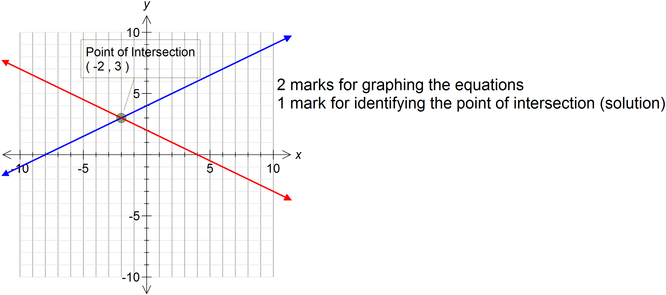

3 58. At a music store, all CDs are the same price and all DVDs are the same price. Andrew buys 6 CDs and 8 DVDs for a total of $126. Jane buys 1 CD and 4 DVDs for a total of $53. Write a linear system and solve the system **algebraically** to determine the price of one CD and one DVD.

Sample Solution:

|  |  |
| --- | --- |
| Let C = price of CDs  Let D = price of DVDs $$\left\{\begin{aligned}6C + 8D = 126 1 mark \\ 1C + 4D = 53 \end{aligned}\right.$$ **Elimination**  6C + 8D = 126  1C + 4D = 53 x 6 0.5 mark  6C + 8D = 126  -6C – 24D = -318  -16D = -192 0.5 mark  -16D = -192  -16 -16  **D = 12** 0.5 mark  C + 4(12) = 53  C + 48 = 53  **C = 5** 0.5 mark  The CDs cost $5 each  The DVDs cost $5 each | Let C = price of CDs  Let D = price of DVDs $$\left\{\begin{aligned}6C+8D=126 \\ 1C+4D=53\end{aligned}\right.$$   **Substitution**  Jane C = 53 – 4D 0.5 mark  Andrew 6C + 8D = 126  6(53 – 4D) + 8D = 126 0.5 mark  318 – 24D + 8D = 126  318 – 16D = 126  318 – 126 = 16D  192 = 16D  192 = 16D 0.5 mark  16 16  **12 = D**  C = 53 – 4(12)  C = 53 – 48  **C = 5** 0.5 mark  The CDs cost $5 each  The DVDs cost $5 each |

**Math 1201 Formulae Sheet**

**(This sheet may be removed from the exam paper.)**

**Measurement**

|  |  |  |
| --- | --- | --- |
| **Imperial** |  | **Imperial to SI Units** |
| 1 ft. = 12 in. |  | 1 in. = 2.54 cm $\dot{=}$ 2.5 cm |
| 1 yd. = 3 ft. |  | 1 mi. $\dot{=}$ 1.6 km |
| 1 mi. = 1760 yd. |  |  |

**Surface Area and Volume**

|  |  |
| --- | --- |
| Surface Area | Volume |
| Cylinder | Pyramid |
| Cone | Cone |
| Sphere | Sphere |

**Math 1201 Multiple Choice Answer Sheet**

**(This sheet may be removed from the exam paper.)**

**Teacher:____­Solutions­­­___ Name:_________________**

|  |
| --- |
| 1. C |
| 2. D |
| 3. B |
| 4. C |
| 5. B |
| 6. D |
| 7. D |
| 8. C |
| 9. C |
| 10. A |
| 11. D |
| 12. C |
| 13. D |
| 14. D |
| 15. A |
| 16. B |
| 17. A |
| 18. D |
| 19. D |
| 20. C |

|  |
| --- |
| 21. A |
| 22. B |
| 23. A |
| 24. B |
| 25. A |
| 26. D |
| 27. D |
| 28. C |
| 29. A |
| 30. C |
| 31. B |
| 32. B |
| 33. A |
| 34. A |
| 35. C |
| 36. D |
| 37. C |
| 38. B |
| 39. D |
| 40. A |