Chapter 5
1. What is the period of 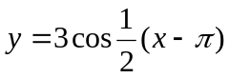?
(A) 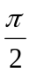 (B)
(C) 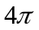 (D) 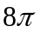
2. What is the range of the function 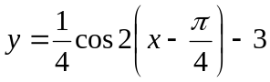?
(A) 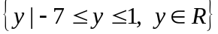
(B) 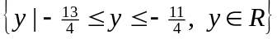
(C) 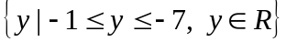
(D) 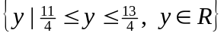
3. What are the transformation of the graph 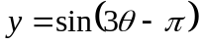?
(A) horizontal stretch by a factor of and a horizontal shift of units right
(B) horizontal stretch by a factor of and a horizontal shift of units right
(C) horizontal stretch by a factor of and a horizontal shift of units right
(D) horizontal stretch by a factor of and a horizontal shift of units right
4. Write the equation of the sine function if the amplitude is 3 and the period is 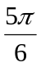?
(A) 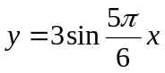 (B) 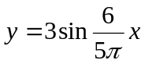
(C) 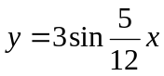 (D) 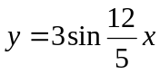
5. If the point 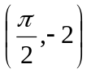lies on the graph of 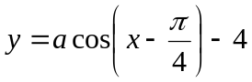, what is the value of a?
(A) 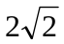 (B) 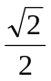 (C) 2 (D) 
6. Which graph has the same y-intercept as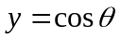?
(A) 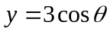 (B) 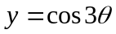 (C) 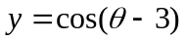 (D) 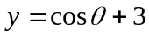
7. The range of a trigonometric function of the form 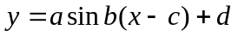is 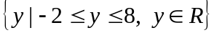. What is the value of d?
(A) 1 (B) 3 (C) 5 (D) 8
8. What is the maximum value of 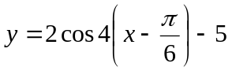?
(A) -7 (B) -3 (C) 3 (D) 7
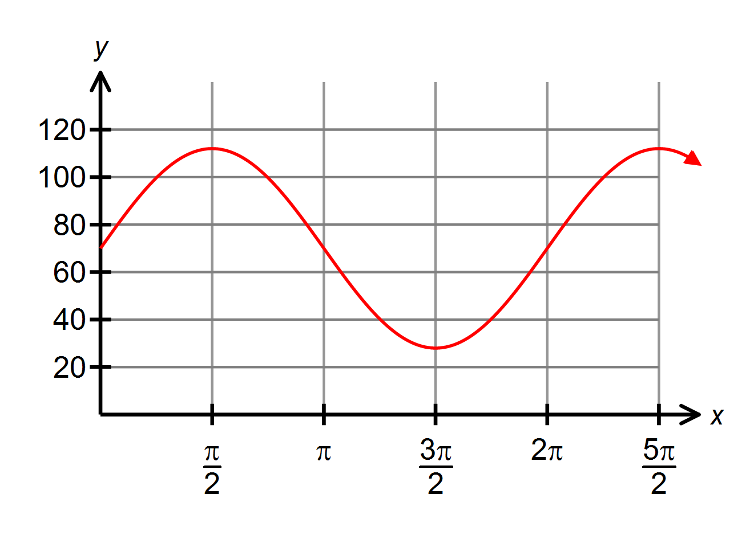9. The partial graph of a trigonometric function is shown. The graph has a maximum value at 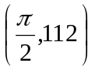and a minimum value at 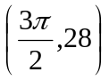. What is the equation of the graph?
(A) 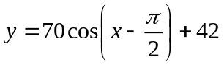
(B) 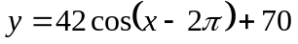
(C) 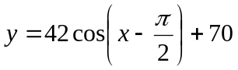
(D) 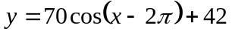
10. What is the domain of 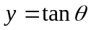?
(A) 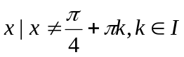 (B) 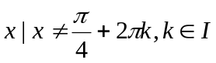
(C) 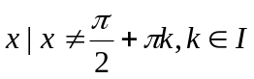 (D) 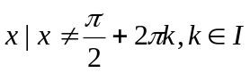
11. Sketch the graph of the function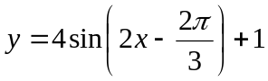.State the Domain/Range.
12. Write the equation for the graph shown in the form and in the form 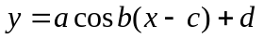.
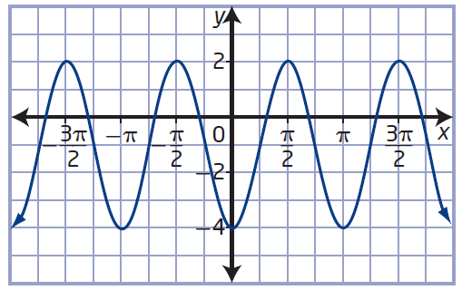

13. A Ferris wheel with a radius of 6m rotates once every 30 seconds. Passengers get on board at a point 1m above the ground at the bottom of the Ferris wheel which is the starting point. Find the function that represents this data and sketch the graph.

14. Determine all solutions, in radian measure, for the equation 

